**Types of bank in US**

Commercial Banks:

Description: Provide a wide range of financial services to individuals, businesses, and governments. Services include accepting deposits, providing business loans, and offering basic investment products.

Examples: JPMorgan Chase, Bank of America, Wells Fargo.

Functions and Services:

Accepting Deposits: Offer various types of accounts such as checking, savings, and certificates of deposit (CDs).

Loans and Credit: Provide personal loans, mortgages, auto loans, and business loans.

Payment Services: Facilitate money transfers, electronic payments, and provide debit and credit cards.

Investment Services: Offer investment products like mutual funds and retirement accounts.

Wealth Management: Provide financial planning and advisory services.

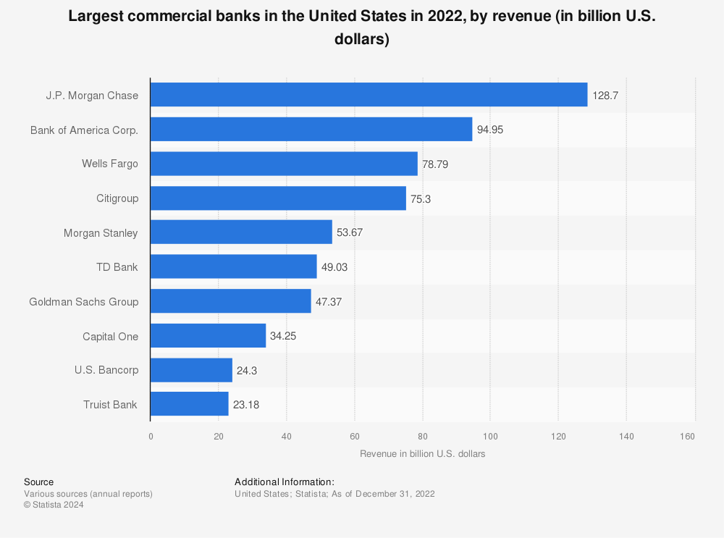

Credit Unions:

Description: Member-owned financial cooperatives that provide similar services as commercial banks but often with better interest rates and lower fees. Membership is typically based on a common bond among members, such as a specific community, workplace, or organization.

Examples: Navy Federal Credit Union, Alliant Credit Union, State Employees' Credit Union.

Functions and Services:

Deposits: Similar to commercial banks, credit unions offer checking and savings accounts.

Loans: Provide personal loans, mortgages, car loans, and credit cards often with lower interest rates.

Financial Education: Offer workshops and resources to help members manage their finances.

Community Focus: Often reinvest profits back into the community or member benefits.



Savings Banks (also known as Savings and Loan Associations or Thrifts):

Description: Focus primarily on accepting savings deposits and making mortgage and other loans. Historically played a key role in housing finance.

Examples: New York Community Bank, Hudson City Savings Bank.

Functions and Services:

Savings Accounts: Focus on helping individuals save money with savings accounts and CDs.

Home Loans: Specialize in mortgage lending and home improvement loans.

Other Loans: May offer personal and auto loans.

Financial Counseling: Provide advice on saving, budgeting, and home buying.

Investment Banks:

Description: Specialize in large and complex financial transactions such as underwriting, acting as an intermediary between securities issuers and investors, facilitating mergers and acquisitions, and providing advisory services.

Examples: Goldman Sachs, Morgan Stanley.

Functions and Services:

Underwriting: Help companies issue new stocks and bonds.

Advisory Services: Provide advice on mergers, acquisitions, and other major financial transactions.

Trading: Engage in trading securities, commodities, and derivatives on behalf of clients.

Asset Management: Manage investments for institutions and high-net-worth individuals.

**Investment Banking Revenues in 2007 and 2021**

In 2007, the investment banking revenues for US bulge bracket firms were:

* [Goldman Sachs](https://www.linkedin.com/company/goldman-sachs/): US$7.5 billion
* [Morgan Stanley](https://www.linkedin.com/company/morgan-stanley/): US$5.5 billion
* [Citi](https://www.linkedin.com/company/citi/): US$5.2 billion
* [J.P. Morgan](https://www.linkedin.com/company/jpmorgan/): US$6.6 billion
* [Merrill Lynch](https://www.linkedin.com/company/merrilllynch/) (acquired by [Bank of America](https://www.linkedin.com/company/bank-of-america/)): US$5.2 billion

By the end of 2021, Goldman Sachs, Morgan Stanley, and JPMorgan had doubled their investment banking income from the peak of 2007, while Citigroup's revenue grew by 50%, and Bank of America fell short of the record set by Merrill Lynch (which it acquired post-GFC) by USD 100 million.

Community Banks:

Description: Smaller banks that serve local communities. They focus on providing personalized service to individuals and small businesses within a specific geographic area.

Examples: First Community Bank, Independent Bank.

Functions and Services:

Personalized Banking: Offer tailored services to meet the needs of local customers.

Local Loans: Provide loans to small businesses and individuals in the community.

Community Involvement: Support local projects and events.

Basic Banking Services: Offer checking and savings accounts, and other standard banking products.

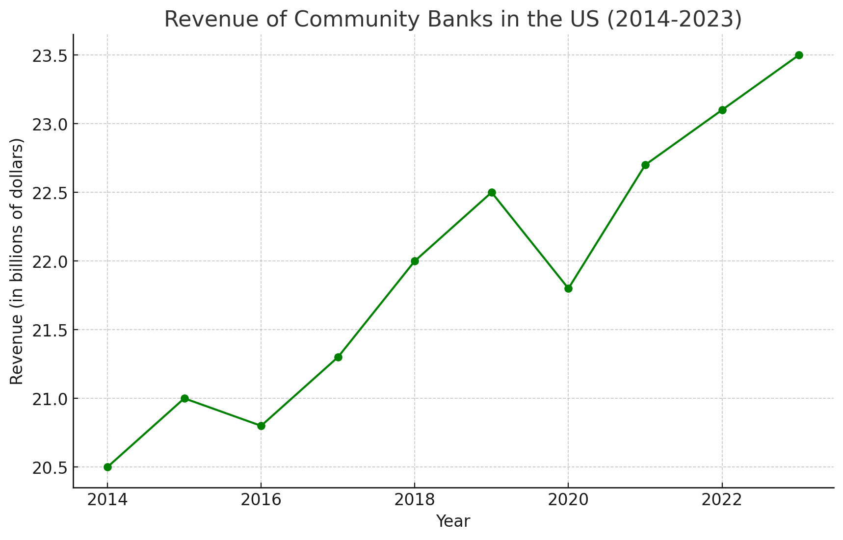

Online Banks:

Description: Operate primarily on the internet, offering banking services without physical branches. They often provide higher interest rates on deposits and lower fees due to reduced overhead costs.

Examples: Ally Bank, Chime, Marcus by Goldman Sachs.

Functions and Services:

Digital Banking: Provide all banking services through online platforms and mobile apps.

High-Interest Rates: Often offer higher interest rates on savings and lower fees due to lower operating costs.

Convenience: 24/7 access to banking services.

Loan Services: Provide personal loans, mortgages, and credit cards online.

Regional Banks:

Description: Operate in specific regions of the country, offering a full range of banking services. They are larger than community banks but smaller than national banks.

Examples: PNC Bank, U.S. Bank, BB&T (now Truist).

Functions and Services:

Full-Service Banking: Offer a wide range of services similar to national banks but focused on specific regions.

Local Expertise: Provide banking solutions tailored to the economic conditions of their region.

Business Services: Offer loans and financial services to regional businesses.

Retail Banking: Provide personal banking services including deposits, loans, and investment products.

Federal Reserve Banks:

Description: Part of the Federal Reserve System, these banks serve as the central bank of the United States. They implement monetary policy, supervise and regulate banks, maintain financial stability, and provide banking services to depository institutions and the federal government.

Examples: Federal Reserve Bank of New York, Federal Reserve Bank of Chicago.

Functions and Services:

Monetary Policy: Implement policies to control inflation, manage employment levels, and stabilize the currency.

Bank Supervision: Regulate and supervise commercial banks to ensure stability and compliance with laws.

Financial Services: Provide services to the U.S. government and other banks, such as currency distribution and check clearing.

Research: Conduct economic research and provide insights on economic trends.

Mutual Banks:

Description: Owned by depositors rather than stockholders. They often function similarly to savings banks but are structured to benefit their members.

Examples: Eastern Bank, Salem Five.

These different types of banks cater to varying needs, from everyday banking and savings to complex financial transactions and investments.

Functions and Services:

Member-Owned: Operate to benefit their members rather than shareholders.

Savings and Loans: Similar to savings banks, focus on accepting deposits and providing home and personal loans.

Community Support: Often involved in supporting local community initiatives.

Dividends: Profits may be returned to members in the form of lower loan rates, higher ssavings rates, or dividends.